
_________________________________________________________________

Access Hours:
Renters: 8 am to 8 pm (unless special arrangements have been made)
Owners: 24/7
_________________________________________________________________

Gate and Security System Activation

We are pleased to announce that the gate and security systems at Storage Works Cumberland are now fully operational.

To ensure smooth access for all tenants, the following entry methods will be used:
- PIN Code - All tenants will receive a unique code
- Key Tag - Provided to all rental tenants for easy access
- Fob - Issued to owners for secure entry

Additional key tags and fobs are available for purchase. Please note that lost key tags or fobs will incur a replacement cost.

Gate Access Information:

The gate will open after you use one of your designated entry methods. Simply use your fob, key tag or manually code in. Please note the key tag must be in close proximity to the reader. On exit slowly approach the gate and it will automatically open and close behind you.

Coding in:
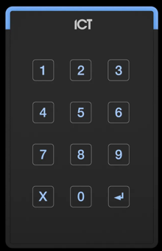
Arrow
- Enter personal ID code provided above
- Push Arrow
- Push ‘X’ to reset

‘X’ resets

Access Hours: You will have access to the facility during from 8 am to 8 pm.

If you need to adjust these hours (and have not done so already), please contact the Storage Works Operations Manager, Deborah Davenport at (250) 336-9134) to discuss other options.

In case of extreme snowfall, the gate will remain open.

Thank you for your cooperation as we enhance security for our facility. If you have any questions please contact:

Deborah Davenport
Operations Manager
Storage Works Cumberland

www.storageworks.online
storageworkscumberland@gmail.com
(250) 336-9134

